After you have thought about this for a while, pass it on to those poor unsuspecting friends you just love to pull something over on.
The Costa Rican Card Trick. Performed by: Carlos
Pick one of the following cards. Don't click on it; just keep it in your head.
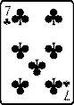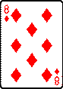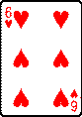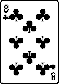
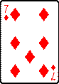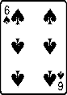
scroll down when you have your card,
Think about your card for 20 seconds in front of Cards .
Carlos will attempt to read your mind!
Scroll down after 20 Seconds
The Great Carlos Has Removed Your Card!
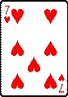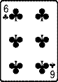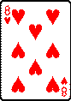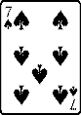
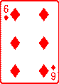
SCARY ISN'T IT.
Now scroll up and do it again, this will freak you out.
Don't ask me because I don't know. Its an "old Costa Rican card trick"..

